https://www.echo-ca.org/article/beginners-guide-hoa-boards-directors-duties-and-responsibilities
Beginner's Guide to HOA Boards of Directors Duties and ...
www.echo-ca.org
Becoming an association board member can be a daunting task. Many new members seek an introductory guide to the duties and responsibilities of boards of directors.

https://www.kppm.com/what-makes-a-great-hoa-board-member/
What Makes a Great HOA Board Member?
www.kppm.com
Here’s what to look for when voting for board members or if you’re thinking of serving on your community’s HOA board. As HOA management professionals, we've ...

https://www.hoaleader.com/public/527.cfm
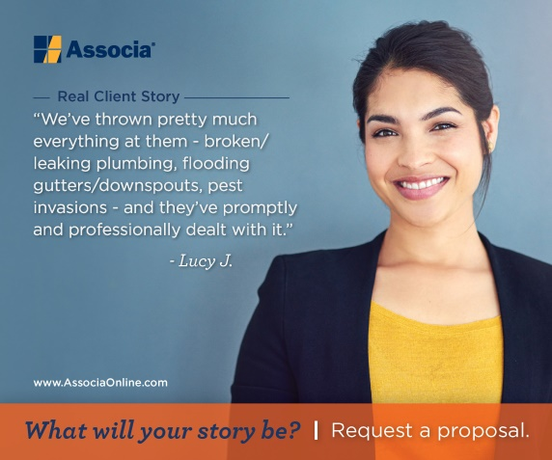 | 10 Traits of Successful HOA Board Members  www.hoaleader.com  What qualities must you have to be a good homeowners association board member? Here, our experts reveal the top 10 tr

